EDUCATIONAL VISIT TO THE DEPARTMENT OF ANTHROPOLOGY, DHSK COLLEGE
DATE: 07.12.2024
A Brief Report
An Educational visit was done by the Higher Secondary students of Kaizen Academy, Dhakuakhana to the Department of Anthropology, DHSK College, Dibrugarh. They visited the Departmental Library, Laboratory, RUSA building, Museum, Photo Gallery etc. The faculty members of the Department interacted with students and teachers of Kaizen Academy. Total number of teachers who visited was five in number along with Vice Principal of the college. Total 47 students visited the Department.
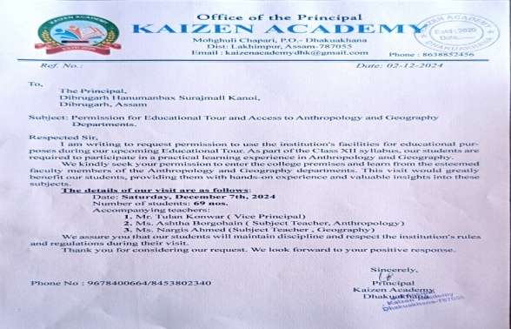 | 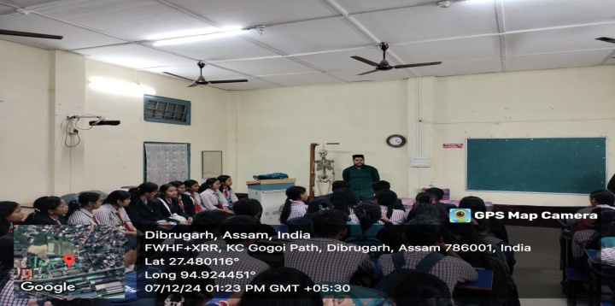
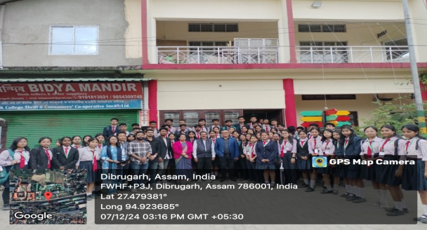 | 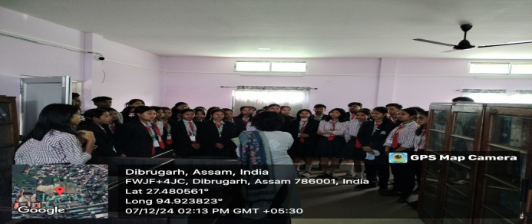



Dr. Sunanda Sahu
H.O.D. & Associate Professor
Department of Anthropology
DHSK College

