PARENT-TEACHER MEETING
Date: 28.03.2025

A Parent-teacher meeting for B.A./B.Sc 2nd Sem (Major) students under FYUGP was organized by the Department of Anthropology, DHSK College to discuss about academic performance, problems encountered, attendance and various other aspects of students.
In the meeting teachers gave information about student’s attendance to their respective guardian and also shared 1st Sessional marks with them. An overview of calculation of internal mark was discussed with the parents. The meeting was successfully organized and parents share their view about their children.

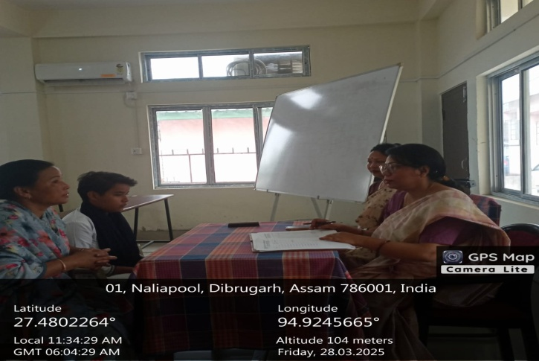 | 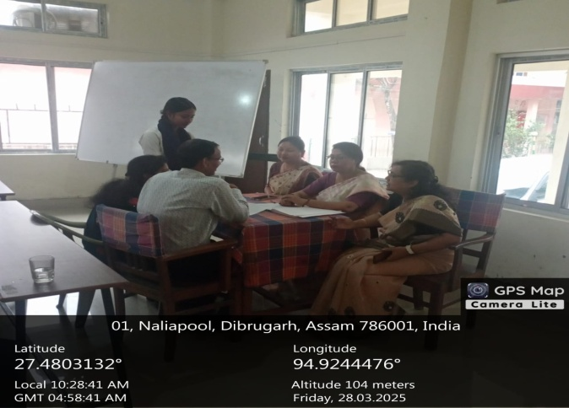
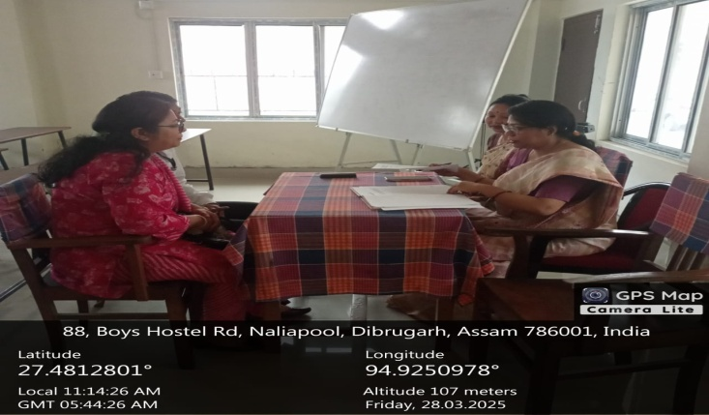 | 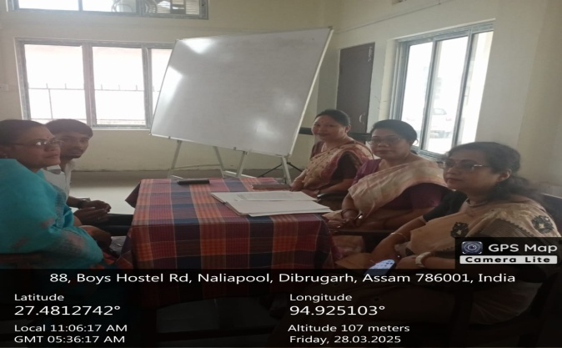


H.O.D, Department of Anthropology
DHSK College

