DEPARTMENT OF ANTHROPOLOGY ORGANISES FELICITATION CUM INTERACTION PROGRAMME ON 18.8.2025
The Department of Anthropology has organized a Felicitation cum Interaction programme on 18th August, 2025 at the Department of Anthropology. In the programme Miss Bhumika Gogoi, a passed out student of B.A. 6th Sem (Major), 2025 was invited. She was felicitated for her outstanding result ie First Class 1st position in B.A. 6th Sem in Anthropology under Dibrugarh university. The programme was started by a brief introduction about Miss Bhumika Gogoi by Dr. Sunanda Sahu (Head of the Department, Anthropology). After that few words were shared by Dr. Moromi Talukdar (Faculty, Department of Anthropology) & Dr. Bhaskar Das (Faculty, Department of Anthropology). Bhargav Chutia, 5th Semester Major Student of the Department has spoken his experience with Bhumika Gogoi as his senior.
In presence of all the faculty members and students of 1st, 3rd, 5th Semester major, felicitation was done. After that Bhumika Gogoi interacted with the newly admitted students of 1st Semester major students of the Department. The interaction was very fruitful, encouraging for the students.
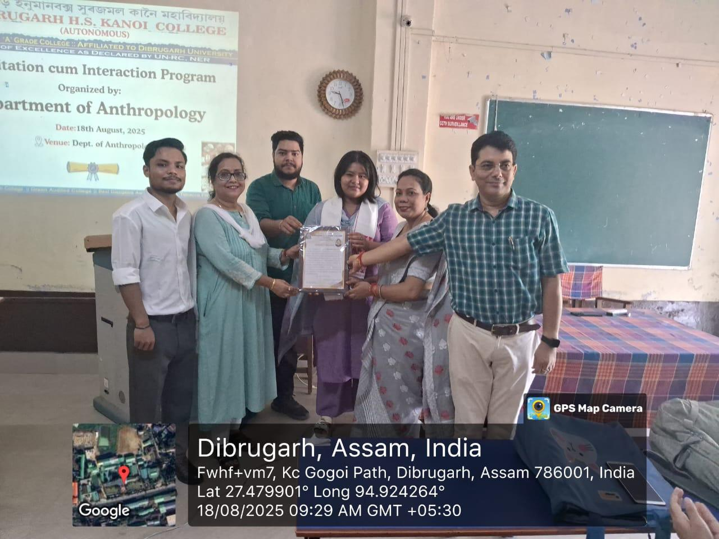 | 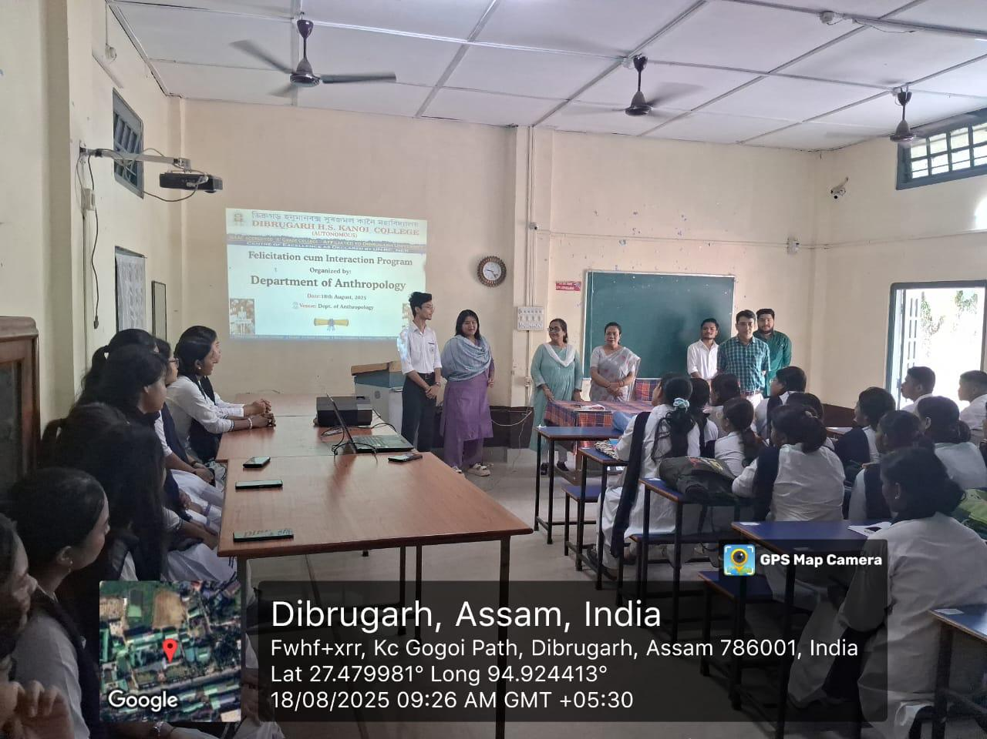

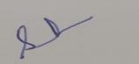
Dr. Sunanda Sahu
HoD, Anthropology, DHSK College

