DHSK College (Autonomous) Commemorates World Ozone Day with Invigorating Talk on Sustainability

DHSK College (Autonomous), in collaboration with ASTEC, Guwahati, observed World Ozone Day with a series of engaging activities on 16th September, 2025. The Department of Zoology hosted an invited talk, poster competition, and social media campaign competition, all centered around the theme "From Science to Global Action" and focusing on "Ozone Layer Depletion, Its Consequences and the Role of Youth in Its Mitigation." The event featured a thought-provoking talk by Dr. Binita Pathak, Assistant Professor from the Department of Physics at Dibrugarh University. Dr. Pathak delivered an insightful presentation on the chemistry of the ozone layer, emphasizing the importance of sustainability and the crucial role of youth in protecting it. Ms. Sankranti Devi, Assistant Professor, Department of Zoology, hosted the event. Dr. Sanchita Boruah, Head of the Department of Zoology, welcomed the gathering with a heartfelt speech. Principal Dr. Sashi Kanta Saikia graced the occasion, delivering an insightful address that highlighted the significance of sustainable practices in ozone layer protection. He emphasized the pivotal role of youth in this endeavor, inspiring the students to take action. The event drew a significant audience, including over 15 faculty members, IQAC Coordinator Dr. Dipankoj Gogoi, and around 150 students. Ms Polly Sarkar, assistant professor, Department of Zoology, delivered the vote of thanks. By organizing this event, DHSK College reaffirmed its commitment to sustainability and environmental protection, aligning with the World Ozone Day theme "Preserving Our Sky, Protecting Our Earth."
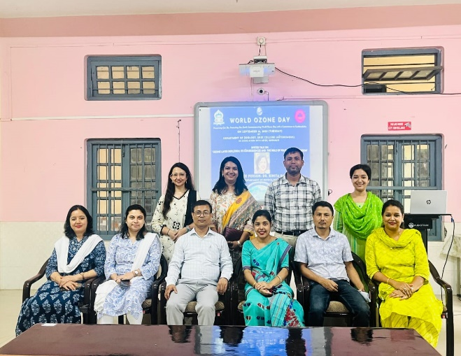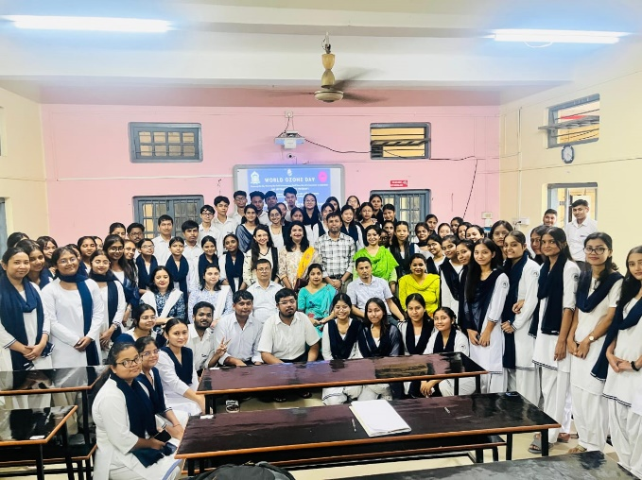
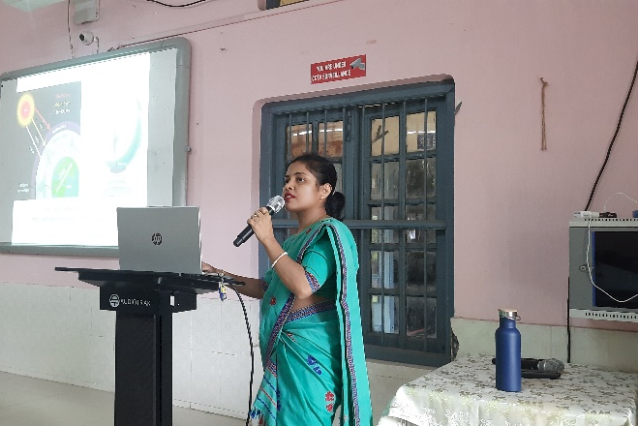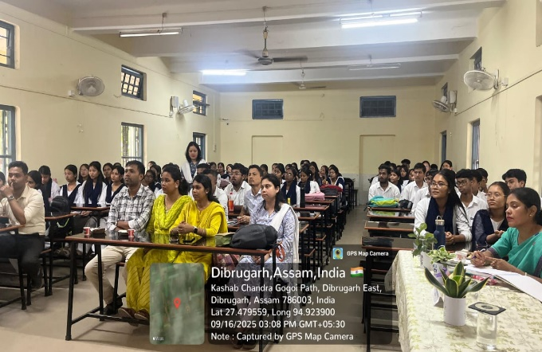
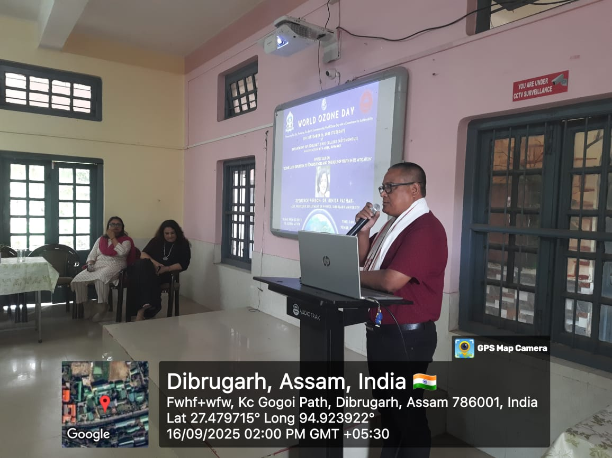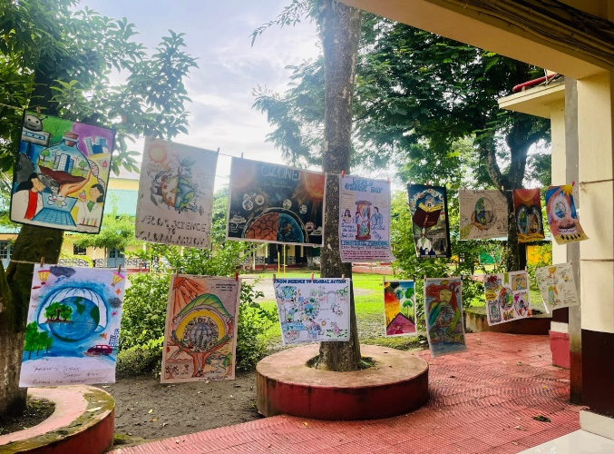

Celebration of World Ozone Day

