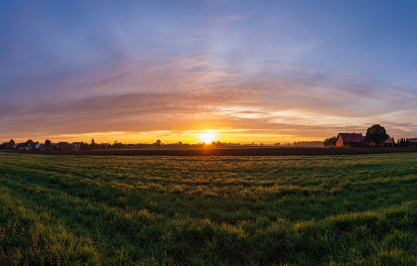
An Educational Tour to
Chawolkhowa Charaihabi Gaon
Dibrugarh, Assam

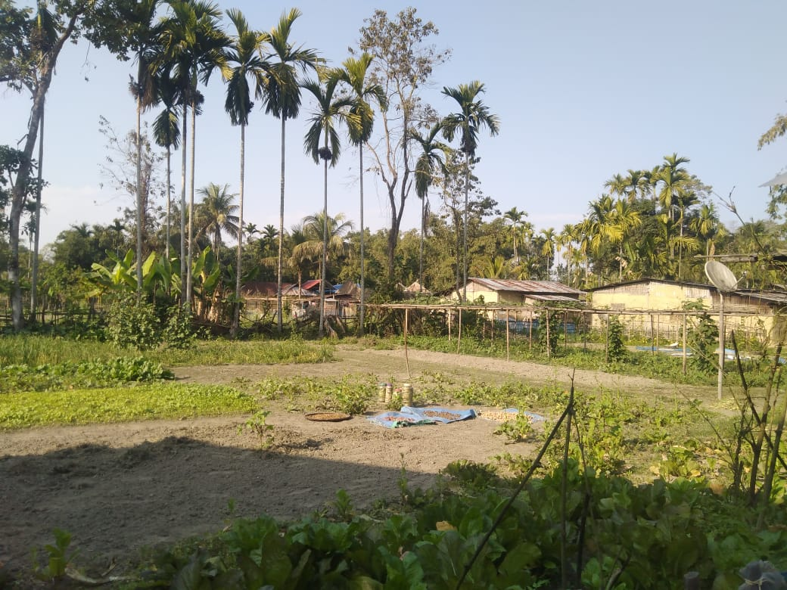
Submitted by : Ranjinee Chetia
Examination : TDC 5th Semester, 2021
Roll no.
Registration No. S1828827
A report submitted to Dibrugarh University as a partial fulfillment of Practical paper 502 of B.A./B.Sc. 5th Semester examination.

Certificate

This is to certify that Miss. Ranjinee Chetia, student of 5th Semester, with honours in Geography, bearing roll no. and registration no. S1828827 has prepared this field report under our guidance and supervision. This report has been submitted as a partial fulfillment of paper 502 for 5th Semester Final Examination under Dibrugarh University.

Mrs. Krishnakshi Saikia
Assistant professor
Department of Geography
D.H.S.K. College

Acknowledgment

I would like to put forward my special thanks of gratitude to Meetali Chaliha( head of the department) Madam, Krishnakshi Saikia Madam, Hemanta Timsinha Sir and Juri Baruah Madam, who accompanied in our field trip to the Chawolkhowa village.
I am overwhelmed to acknowledge our head of the department Meetali Chaliha Madam for forwarding her permission towards our field trip to Chawolkhowa Gaon,along with our teacher Krishnakshi Saikia Madam and Juri Baruah Madam, whoes tireless guidance have ensure us to completion of this report on ' An Educational Tour to Chawolkhowa Village, Dibrugarh, Assam'.
A heartfelt thanks to our principal sir as well, as he was the one who had avail the opportunity for the students of 5th semester of geography department.
Ranjinee Chetia
Department of Geography
D.H.S.K. College
Dibrugarh-786001
Content

- Introduction 5
- Importance and Utility of the Field Study in Geographical Analysis 7
- Program and Arrangments of the study
conducted. 9
- Aims and objectives of the study 11
- Methodology 12
- Route map of the trip. 13
- Description of the place visited. 14
- Physiographic dataset. 15
- Demographic dataset. 17
- Problems and Suggestions 24
- Findings and conclusions 26
- Photo gallery. 28
- References. 30

Introduction

A field study refers to the learning experiences at some specific place, with a special purpose and with the motive of a prompt return. It allows the students to gather primary data through direct observation and experience. It allows the students to be involved in new environments.It is different with an excursion in the way that, an excursion is usually made for a longer time while a filed trip is done for a short period of time. Field studies ranges from short walk in a nearby locality to vehicle excursion for some distance for several hours to a full day. Investigation or students in field studies observes the users for the inhabitants of a place, as they work, taking notes on particular activities and often asking questions to those inhabitants of the concerned area, in order to have a proper cognizance of the various landforms, socioeconomic conditions, settlement pattern etc.
This further assists the investigatiors or students to acquire accurate data and acknowledge of the concerned area. Moreover, the investigatiors developed self confidence, initiatives and leadership within themselves. It courageous the development of social, personal, and study skills. It is done solely with an aspiration to acquire information and knowledge. It provides direct source of knowledge, disminishes the classroom boredom, offers different cultural experience etc.

Importance and Utility of the Field Study in Geographical Analysis :

Field study refers to a short trip done for several hours or a full day, to a particular locality by a group of people for the purpose of education or leisure. It helps in the development of certain aspects among the participants.

The Importance of a Field Study are —

- The field study allocates direct source of comprehension (primary information) to the investigatiors.

- It enables to interpret and better understand the situation and processes, in terms of landforms, socioeconomic conditions etc, of the particular area visited.

- It further allows to gain experience in integrating the theoretical perspectives learner in the classroom with experiences gained in the field.

The Utility of Field Study in Geographical Analysis are—

- The field study provides the opportunity to collect acquire correct knowledge and information directly from an area, without any involvement of any secondary source.

- Due to the primary data being the most accurate form, the proper analysis of an area's physiography and socioeconomic conditions, must be analysed through primary data only.

Program and Arrangment of the Study Conducted :

The pre-requisite of our examination in 5th semester, entailed us to participate in a departmental field trip to Chawolkhowa village, Dibrugarh, Assam. Our team consisted of 28 individuals, out of 24 were students and 04 were teachers. The journey from our college commenced on 30 January,2021 at 9:00 am from D.H.S.K. College. The journey has been made through a traveller car. We had our breakfast at 11:00 am at the time we reached the bank of the river Brahmaputra in near Bogibeel bridge. The construction of the main path to the village has made transportation much easier. After completing breakfast we headed towards the village which is located at 4km from the river Brahmaputra.
We gathered all our necessary details of the village like the area's landforms, settlement pattern, socioeconomic conditions etc. We were been provided with maximum of the necessary details about the village by the head of the Panchayat.
While returning, we had our lunch at the bank of the river Brahmaputra around 4:00pm. Eventually, we arrived Dibrugarh town by 7:30pm. in the evening and were all dispersed, by going in one's own respective residence.

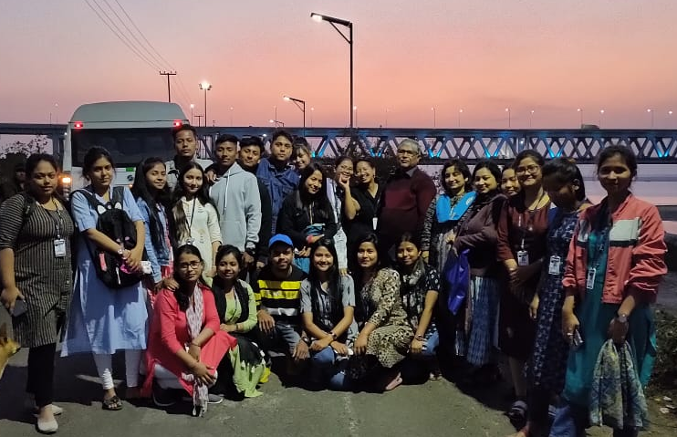

Aims and Objectives of the Study :

The field study aims to provide the students with significant of geographical importance relating to the landforms, settlement pattern, laduse pattern and socio economic conditions of the village Chawolkhowa, Dibrugarh, Assam, and also to introduce them with the concept ideas and experiences that cannot be provided in a classroom environment, by interacting with the physical environment.

The objectives are—
- To acquire useful information
- Settlement pattern
- Socio- economic conditions of the village
- To acquire valuable qualitative and effective learning, experience about the development of the village.

Methodology

Due to the sudden and short trip the type of study and analyses was not much descriptive. The information gathered for this report was both primary and secondary in nature, as the use of internet was the done for certain knowledge of a place.

- Primary data
- Observation by own
- Interaction with local people

2. Internet
- https://villageinfo.in/assam/dibrugarh/dibrugarh-west/chawolkhowa-charaihabi-gaon.html
- https://villagemap.in/assam/dibrugarh/dibrugarh+west/1625400.html

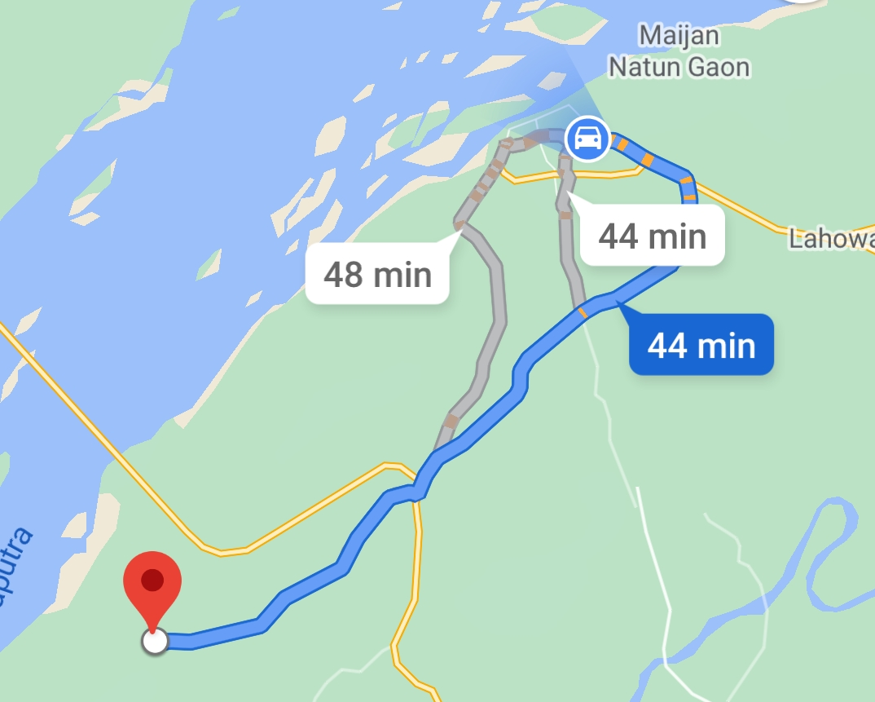
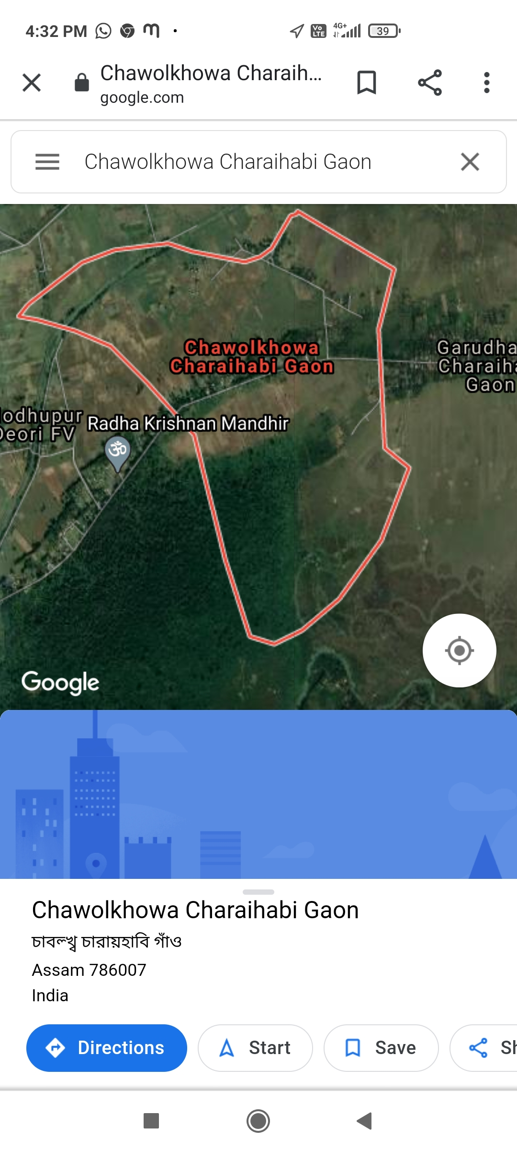
Route Map of The Trip :
Description of the place visited

Introduction & Location : Chawolkhowa Charaihabi Gaon village is located in Dibrugarh West Tehsil of Dibrugarh district in Assam, India. It is situated 23km away from Dibrugarh, which is both district & sub-district headquarter of Chawolkhowa Charaihabi Gaon village. As per 2009 stats, Bogibil is the gram panchayat of Chawolkhowa Charaihabi Gaon village.
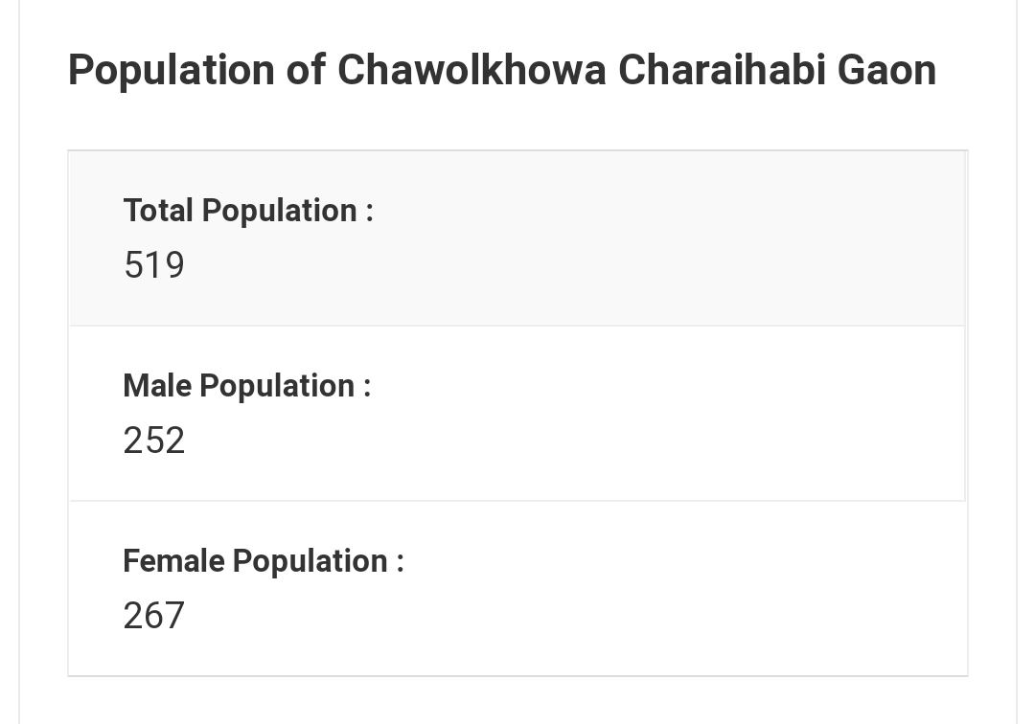
The total geographical area of village is 132.65 hectares. Chawolkhowa Charaihabi Gaon has a total population of 519 peoples. There are about 93 houses in Chawolkhowa Charaihabi Gaon village. Dibrugarh is nearest town to Chawolkhowa Charaihabi Gaon which is approximately 23km away.
Nearby villages of Chawolkhowa Charaihabi Village :
- Laruajaan Gaon
- Jagalani Gaon
- Shaahjan Gaon
- Walkhabi Gaon
- Kawaimari Gaon

Physiographic dataset

Landforms of the village : Chawolkhowa Charaihabi Village located in a plain area formed with alluvial soil. The nature of the land of the whole populated area and the agricultural fields are highly depends upon the river Brahmaputra located near the village.

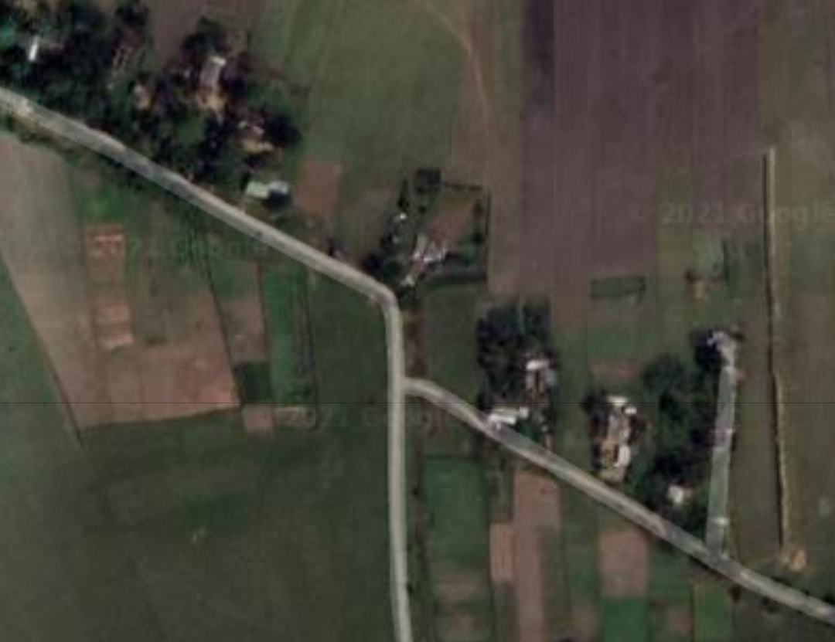
Settlement pattern of the village : A settlement usually referred to a colony or a small community of people living in a particular religion while the settlement pattern refers to the shape of pattern of a settlement existing in a particular region. Settlement pattern can be classified into compact settlement, semi compact settlement, dispersed settlement, nuclear settlement and linear settlement. The Chawolkhowa Charaihabi Village cover an area of 132.65 hectares comprises only 85 households. The houses of the village are seen to be located close to each other. It this, signifies compact settlement. Also the linear settlement can be seen near the main road of the village.

Landuse pattern : It is the layout or the arrangement of the uses of the land. It signifies how the people of the particular region utilise the available land. It also signifies the socio economic condition of the particular area to some extent. The Chawolkhowa Charaihabi Village have utilise the available land of the village in the following ways or pattern —
- Cultivation : The maximum percentage of the total
land area of the village has been used for cultivation. As agriculture is the main activities of the village. The people of the village are engaged in the cultivation of rice, potato, banana, coconut, bettlenuts and other vegetables.
- Grazing area : As people of the village are engaged in primary activities some percentage of land is used for livestock, rearing and grazing both for domestic perposes, animals such as cow, pig, goat, buffaloes etc are the reared and grazed in the land of the village.
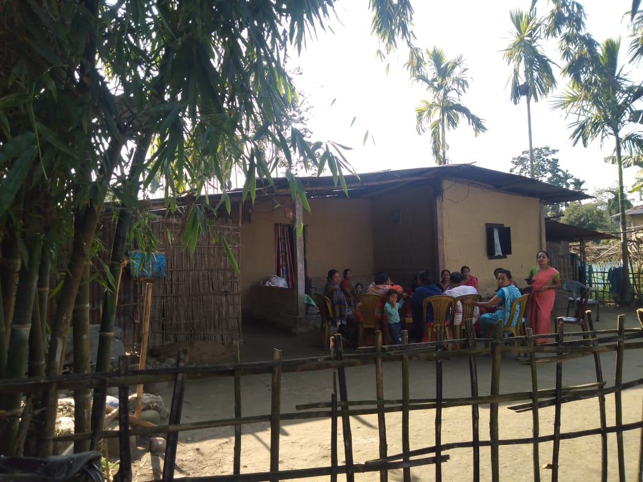
- Residential area : The most important aspect of the people of a region is to give emphasize upon the shelter of their own. So it is of any region pattern of landuse to use it for their residential purpose. Similarly the people of Chawolkhowa Charaihabi Village has also used their land of residential purpose by the establishment of their own respective houses.

Demographic dataset

In Chawolkhowa Charaihabi Gaon village population of children with age 0-6 is 88 which makes up 16.96 % of total population of village. Average Sex Ratio of Chawolkhowa Charaihabi Gaon village is 1060 which is higher than Assam state average of 958. Child Sex Ratio for the Chawolkhowa Charaihabi Gaon as per census is 956, lower than Assam average of 962.
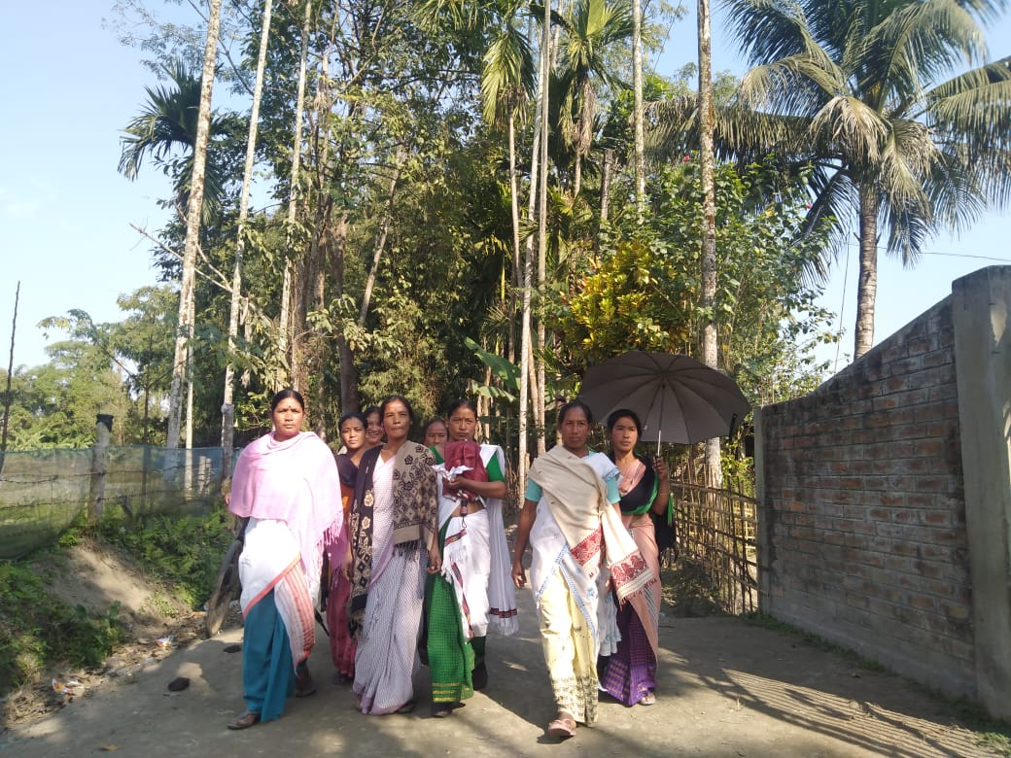
Chawolkhowa Charaihabi Gaon village has higher literacy rate compared to Assam. In 2011, literacy rate of Chawolkhowa Charaihabi Gaon village was 80.74 % compared to 72.19 % of Assam. In Chawolkhowa Charaihabi Gaon Male literacy stands at 83.57 % while female literacy rate was 78.13 %.
As per constitution of India and Panchyati Raaj Act, Chawolkhowa Charaihabi Gaon village is administrated by Sarpanch (Head of Village) who is elected representative of village. Our website, don't have information about schools and hospital in Chawolkhowa Charaihabi Gaon village.

Cast factor : In Chawolkhowa Charaihabi Gaon village, most of the villagers are from Schedule Caste (SC) & Schedule Tribe (ST). Schedule Caste (SC) constitutes 55.49 % while Schedule Tribe (ST) were 43.16 % of total population in Chawolkhowa Charaihabi Gaon village.
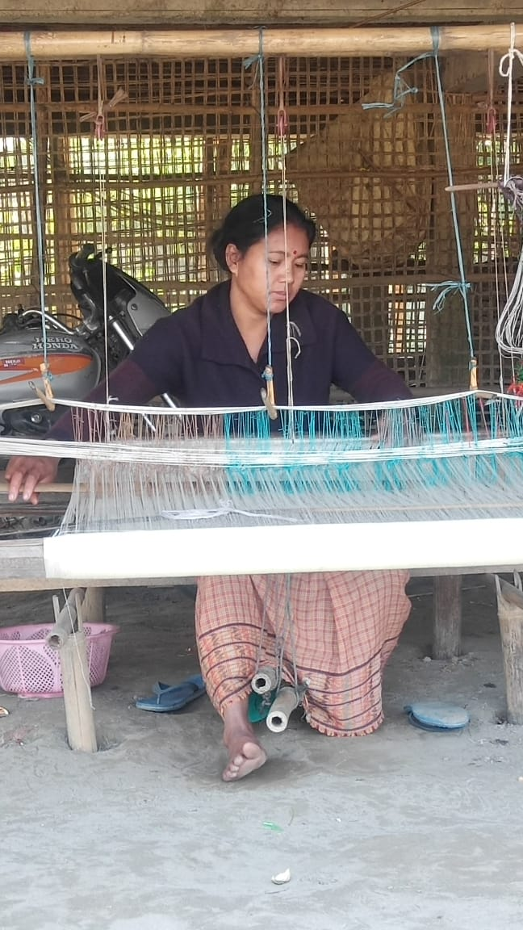
Work profile : In Chawolkhowa Charaihabi Gaon village out of total population, 122 were engaged in work activities. 79.51 % of workers describe their work as Main Work (Employment or Earning more than 6 Months) while 20.49 % were involved in Marginal activity providing livelihood for less than 6 months. Of 122 workers engaged in Main Work, 92 were cultivators (owner or co-owner) while 0 were Agricultural labourer.

Particulars Total Male Female
Population 519 252 267
Child (0-6) 88 45 43
Schedule Caste 288 141 147
Schedule Tribe 224 108 116
Literacy 80.74 % 83.57 % 78.13 %
Total Workers 122 99 23
Main Worker 97 - -
Marginal Worker 25 9 16

Educational facilities : The village has a few number of government primary school and a High school. But most of their students are used to go Bogeebil Sampura Kendriya Vidyalaya, which located in Kamar Gaon, Bogibeel.
Medical facilities : There is no health care centre located near or in the village. Maximum percentage of the families used to go Assam Medical College located in Dibrugarh town. Maximum number of women due to pregnancy couldn't go hospital because of long distance and the high cost of medical facilities. Therefore they have to give birth inside the home.
Cultural Pattern : The population of the Chawolkhowa Charaihabi Village belongs to Nepali community and Missing tribe. They celebrate their own festivals with the bond of togetherness. Also they celebrate the Assamese harvesting festivals. Their food and dress variability is much colorful as a whole but with the developing times they used to wear formal, sarees and Assamese wears.
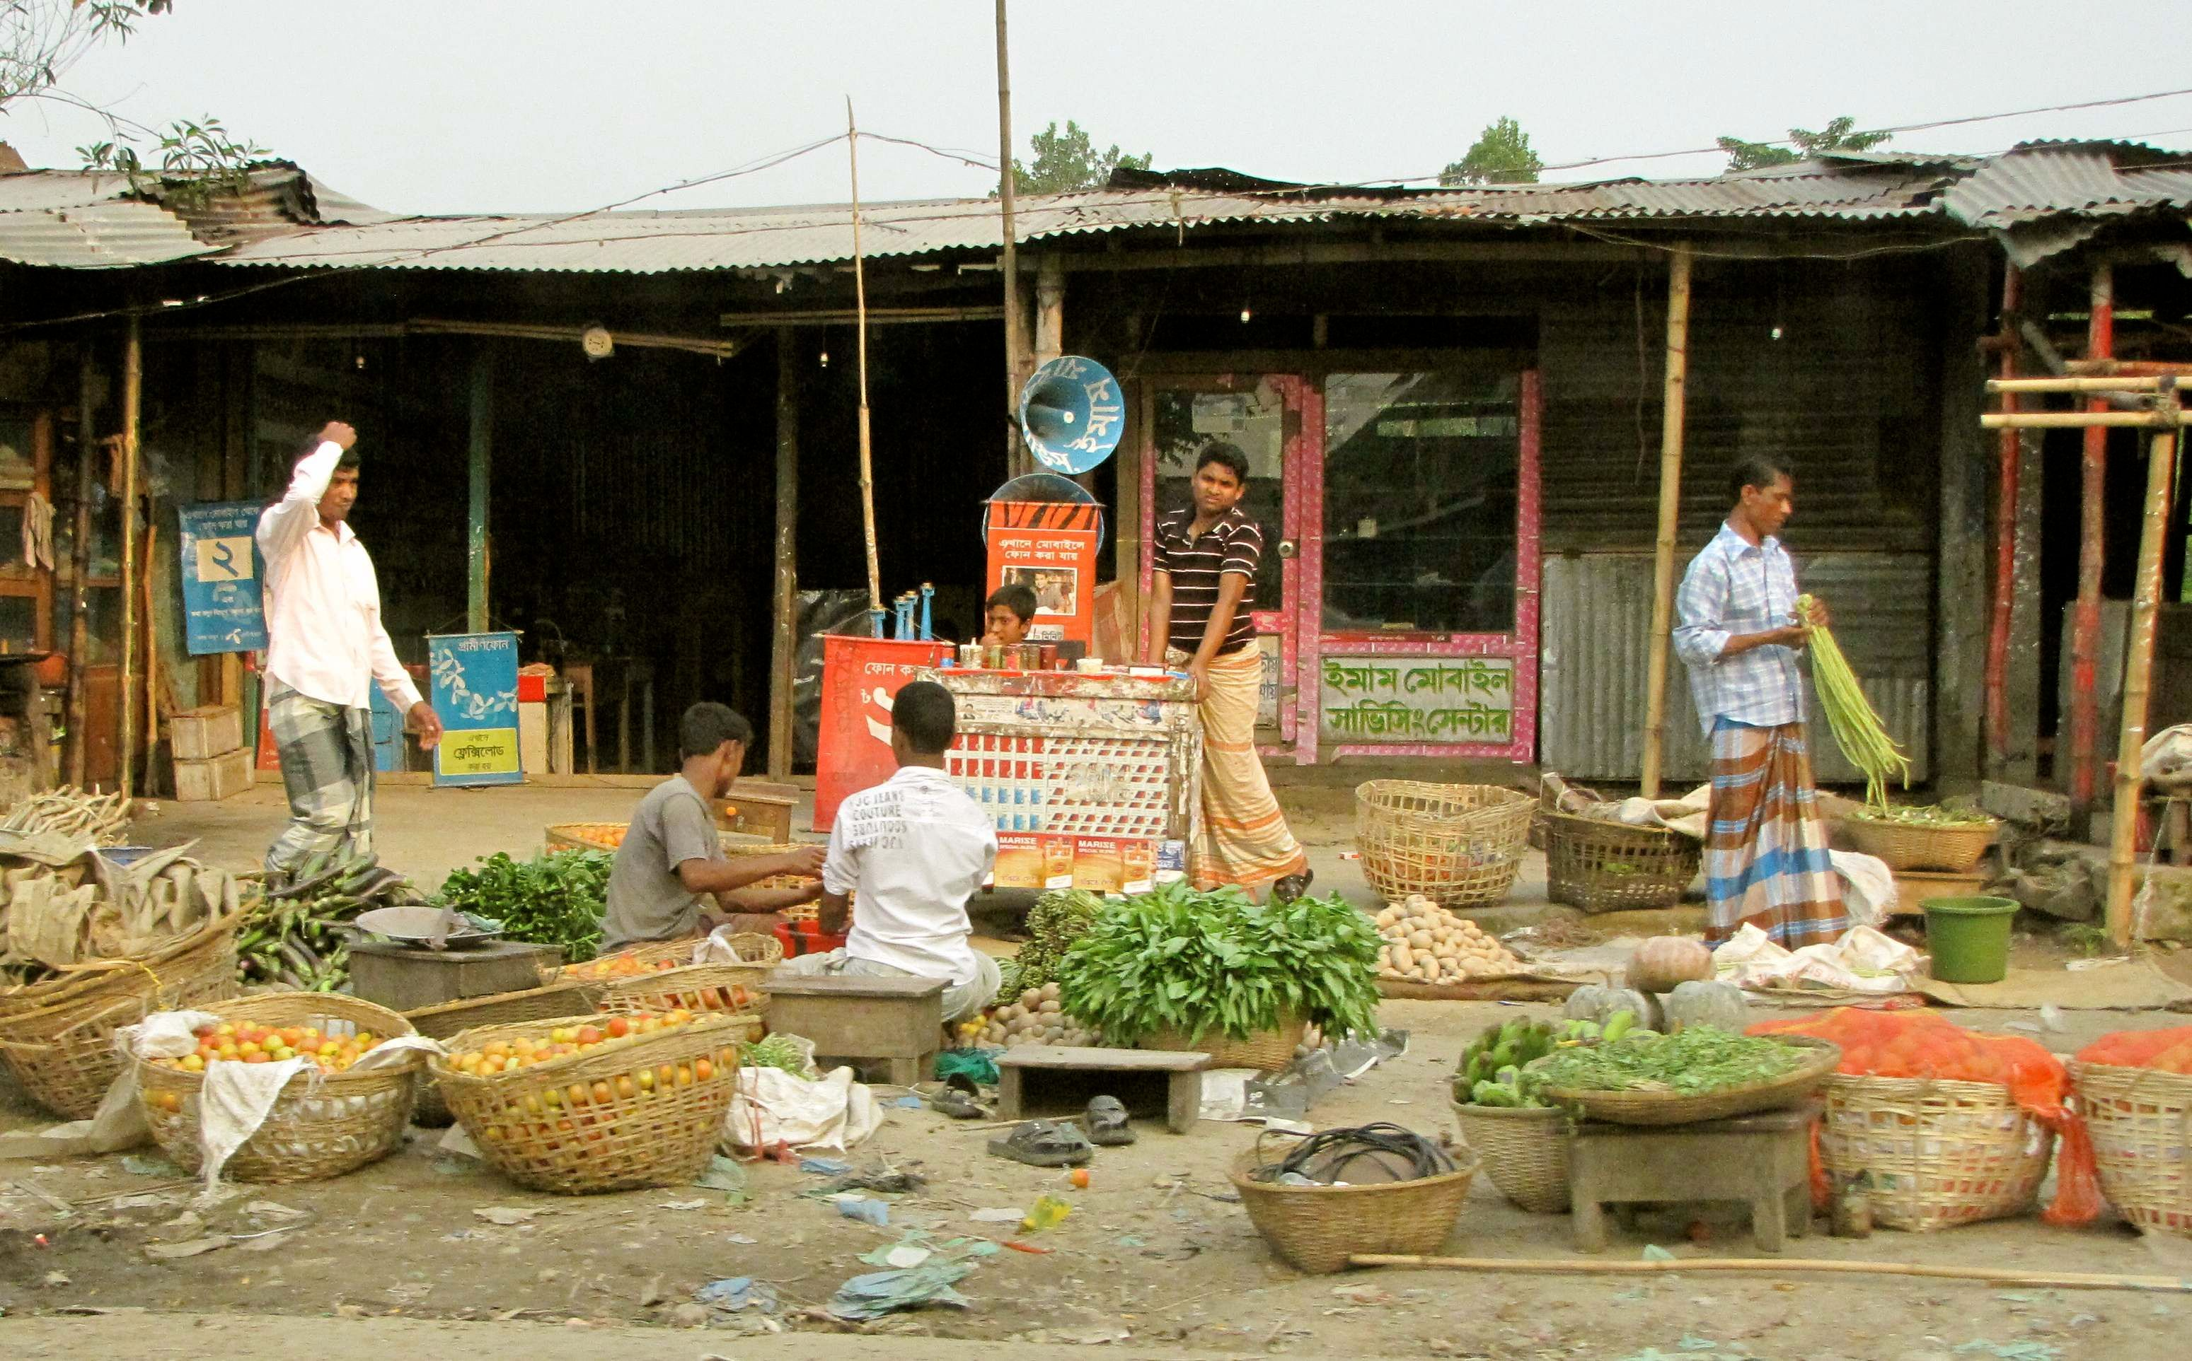
Market Facilities : The people of the village depends upon the nearby local markets in order to accomplish their basic necessities of food, clothing and other purpose. As there are no markets and a number of shops within the village itself. They have to go nearest town of Dibrugarh in order to acquire the basic goods which are not available in the nearby local markets. Moreover there are some fair price shop located at the village from which the village people parches the basic things like rice, oil, kerosene and other things available in the shop. Ration cards are been provided to the villagers below poverty line (BPL) in order to parches the goods from the fair price shop.
Government Facilities : The people of the village to some extent is served by the government facilities of Indira Gandhi Awas Yojna, Pradhanmantri Sauchalaya Yojna, MGNREGA etc. Funds are received by the people of the village under special and emergency circumstances.
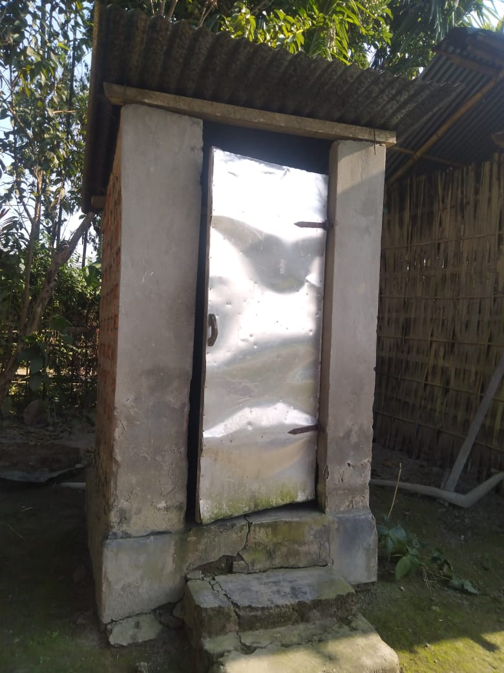
However, the people of the village has to submit an application to the MLA, under any necessary conditions required for the village, in order to have those conditions to be fulfilled. Moreover, it can be seen that there is no proper facilities provided by the government, in order to have a good maintenance of the government primary school and public health centre located in the village. Along with it no proper facilities are been provided towards the good maintenance of the roads. Moreover, government hasn't taken yet initiatives for the establishment of higher educational institution or proper hospital in or near the village.
Economic Condition : The people of the Chawolkhowa Charaihabi Village are mainly engaged in primary and secondary activities. About 40-50 people out of the total population are engaged in secondary activities like government services, and the rest of the population are engaged in primary activities like farming and fishing. Most of the people are engaged in agricultural activities due to availability of fertile land and soil, the source of which is the presence of the Brahmaputra river. They used power tiller and also traditional methods for the cultivation purpose. Besides, they also used rice meals for removing the husk of the grains and producing edible rice.
Annual Income : Being engaged in both government activities and agricultural activities which is done both for, commercial and subsistence purposes, the annual income of the each family of the village of Chawolkhowa Charaihabi is 60,000 to 1,00000 lacs. approximately.
Transport and Communication : There is public bus service available in the village in order to go to the nearby towns from the village itself. People have also personal vehicles for transport.
The only connectivity system of the village is by road. Except the main road of the village, the other roads are made of gravel by MGNREGA policy.

Suggestions and Conclusions

The Chawolkhowa Charaihabi Village which is located in the Dibrugarh district, a moderate livelihood being maintained by the inhabitants of the village. There are certain problems being confronted by the people, which is necessary to put a light on. Some problems along with some suggestions are also been discussed which may make the village little developed as compared to the present day to some extent.
Problems :
- Although a government primary school is present within the village it is not been properly constructed and maintained. Besides the children of the village can't Persie higher education for which they have to migrate to other places.
- There is no any primary health centre located in village. In case of emergency and some major health issues they have to travel 20-25 km. which is very time consuming.
- Another matter of concern is the proper construction of the roads of the village. The roads of the village is not fully metaled.
- The lack of public vehicle service, the villagers faces the problem of transportation during a day.
- Proper mechanisation for agricultural perposes is absent in the village.
- The flood is the major problem of the village, as it comes one in a duration of 2-3 year.

Suggestion :
  - Government should take steps for construction of the primary school regarding its infustructure as it is the only institution present in thee village, and the only way for the children to peruse their education to a primary level.
  - It's very necessary a primary health centre for the purposes of any emergency case or basic aids.
  - The concerned MLA of the village should take steps for proper construction and maintenance of the village. So that, at least the inhabitants doesn't face the difficulty to go through the path of the village in time of heavy rain.
  - Implimentation of proper mechanisation in making of embankments and also in agriculture as their only source is agriculture.

Findings and Conclusion

We got to cognisize about diverse certitude related to the respective place of Chawolkhowa village located at Bogibeel of Dibrugarh.
Presence of 85 households in the village and the area of 132.65 hectares, the resultant settlement pattern is seen to be in the compact and semi- compact form. The Socio-economic conditions of the people of the village is accompanied by primary and secondary activities. The livelihood of the people of the village is moderate enough with their annual income of 60,000 to 10,0000 lacs. There's no doubt the Chawolkhowa Charaihabi Village is beautiful with cheerful people being it's inhabitants. The village should be developed more by diminishing the major problems being confronted by the people of the village. Although those problems doesn't come in light of the eyes of the government immediately. This will result it significance to grow by being an worthy village of Bogibeel to visit upon.

Photo gallery :

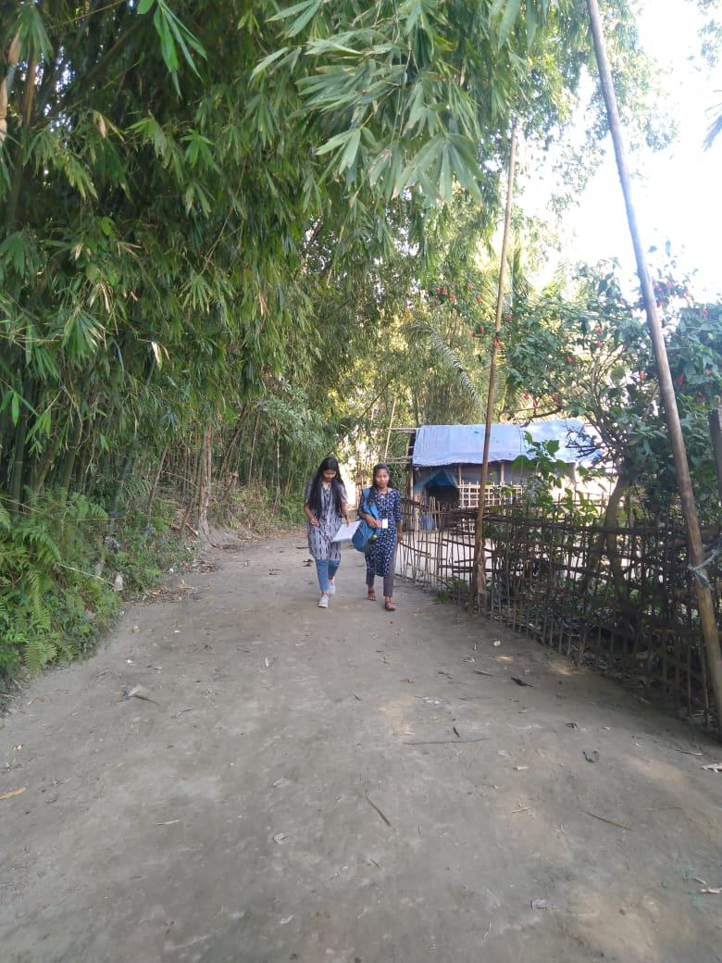
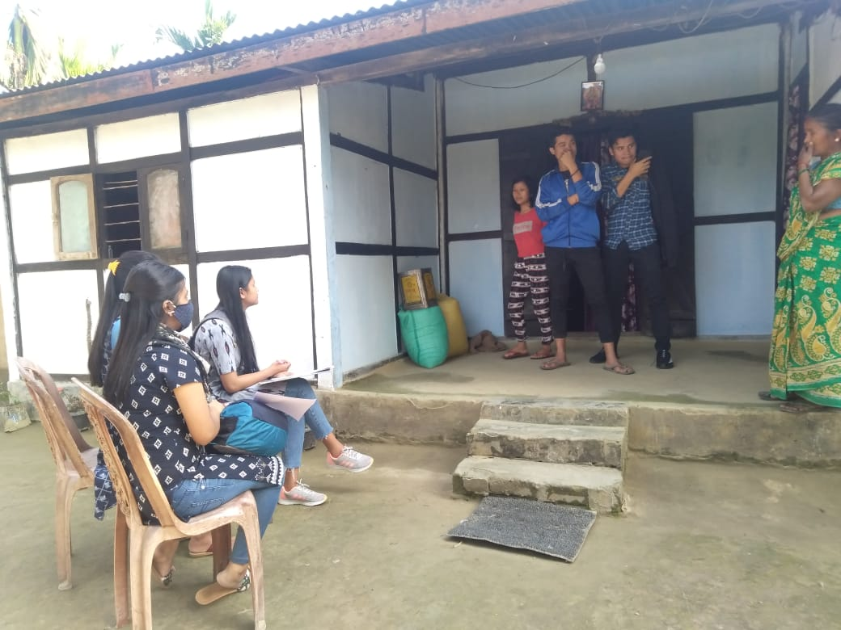
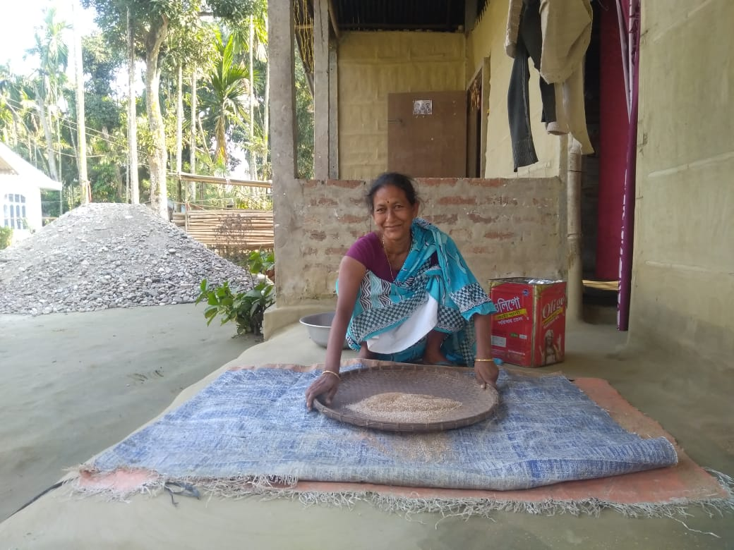
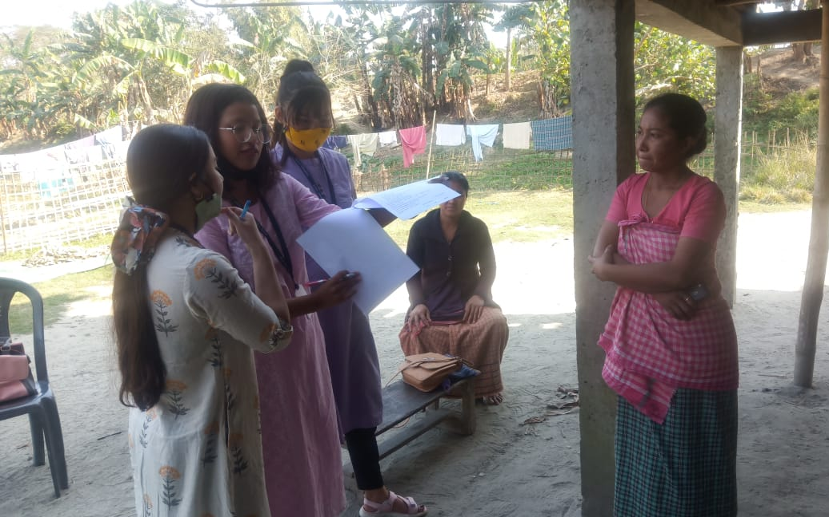
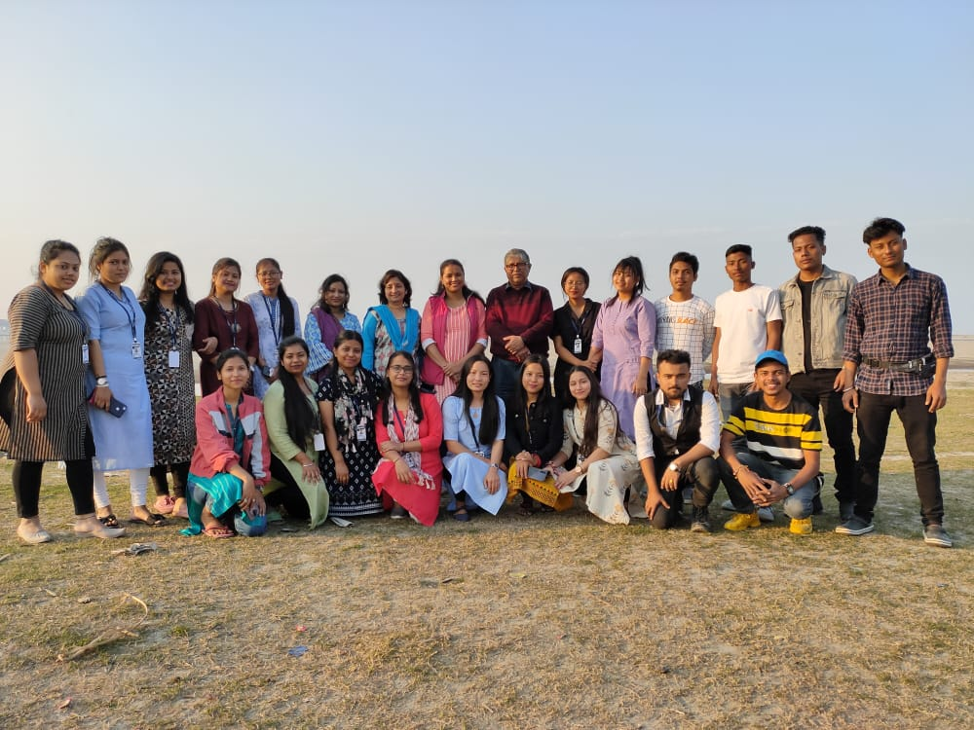
References :
1. Primary data
- Observation by own
- Interaction with local people

2. Internet
- https://villageinfo.in/assam/dibrugarh/dibrugarh-west/chawolkhowa-charaihabi-gaon.html
- https://villagemap.in/assam/dibrugarh/dibrugarh+west/1625400.html

